|  |  |
| --- | --- |
| Roll. No.: A016 | Name: Varun Khadayate |
| Sem/Year: VII/4 | Batch: 1 |
| Date of Experiment: 13/08/2022 | Date of Submission: 13/08/2022 |
| Grade -- |  |

Study of ns2

# What is NS2

NS2 stands for Network Simulator Version 2. It is an open-source event-driven simulator designed specifically for research in computer communication networks.

# Features of NS2

1. It is a discrete event simulator for networking research.

2. It provides substantial support to simulate bunch of protocols like TCP, FTP, UDP, https and DSR.

3. It simulates wired and wireless network.

4. It is primarily Unix based.

5. Uses TCL as its scripting language.

6. Otcl: Object oriented support

7. Tclcl: C++ and otcl linkage

8. Discrete event scheduler

# Basic Architecture

NS2 consists of two key languages: C++ and Object-oriented Tool Command Language (OTcl). While the C++ defines the internal mechanism (i.e., a backend) of the simulation objects, the OTcl sets up simulation by assembling and configuring the objects as well as scheduling discrete events. The C++ and the OTcl are linked together using TclCL

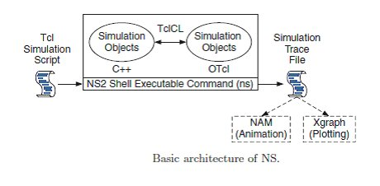

# Conclusion

Hence we were able to perform the experiment.